Cloud Computing &

Cloud Robotics

2018

**Actividad Final**

Abba, Pedro Nicolás

Ares, Charo

Galán, Martín Andrés

# 

# 

Para la Actividad final se nos asignó un AlphaBot2 para manejar desde la herramienta Node-RED. Los kits de robot AlphaBot2 incluyen un chasis (chasis AlphaBot2-Base) y una placa Rasperry Pi Zero W.  
Cuenta con las funciones de robot seguimiento de línea, mecanismos para evitar obstáculos, conectividad Bluetooth / infrarrojo / WiFi, monitoreo de video, etc.

Más específicamente, sus características son:

* Interfaz de control AlphaBot2
* Regulador de voltaje 5V
* Interfaz Raspberry Pi
* ST188: sensor fotoeléctrico infrarrojo reflectante, para evitar obstáculos
* ITR20001 / T: sensor fotoeléctrico infrarrojo reflectivo, para seguimiento de línea
* Rueda omnidireccional.
* Zumbador
* FE1.1S: chip USB HUB
* 12M cristal
* USB TO UART: fácil de controlar el Bot a través de UART
* Interfaz USB HUB: extiende el puerto USB de Raspberry Pi Zero
* CP2102: convertidor de USB a UART
* PCA9685: servo-control
* TLC1543: chip de adquisición AD de 10 bits, permite al Pi usar sensores analógicos
* Servo
* Indicadores USB
* Puertos USB: más capacidad USB

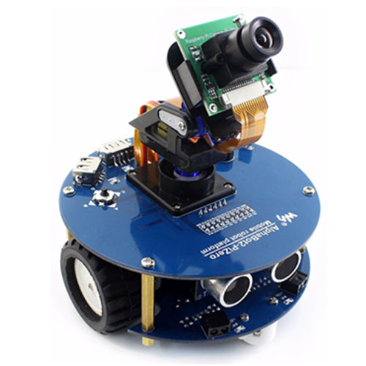

Para descubrir cómo funciona el robot vamos a acceder a las librerías de la Raspberry que están programadas en lenguaje Phyton. Tomando esto como ejemplo intentaremos darle algunas de las mismas funcionalidades al robot desde el flujo de Node-RED.

Nos conectamos con el robot a través de una consola de PuTTy:

Ingresamos usuario y contraseñas otorgadas por la cátedra

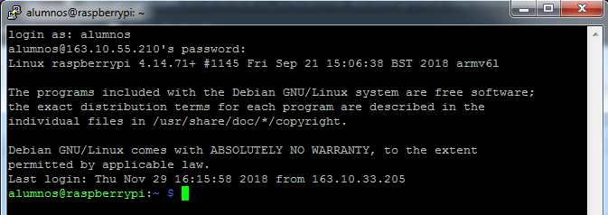

Analizamos las carpetas y archivos de la placa y encontramos los ejemplos que nos ayudarán a entender el funcionamiento del robot.

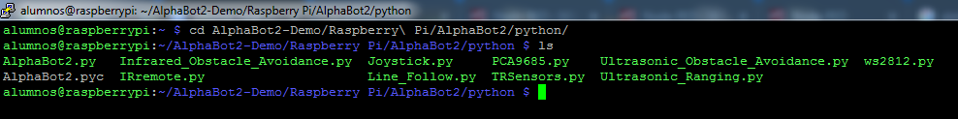

Una vez leídos los ejemplos, nos disponemos a ingresar a Node-RED lo hacemos con la dirección:

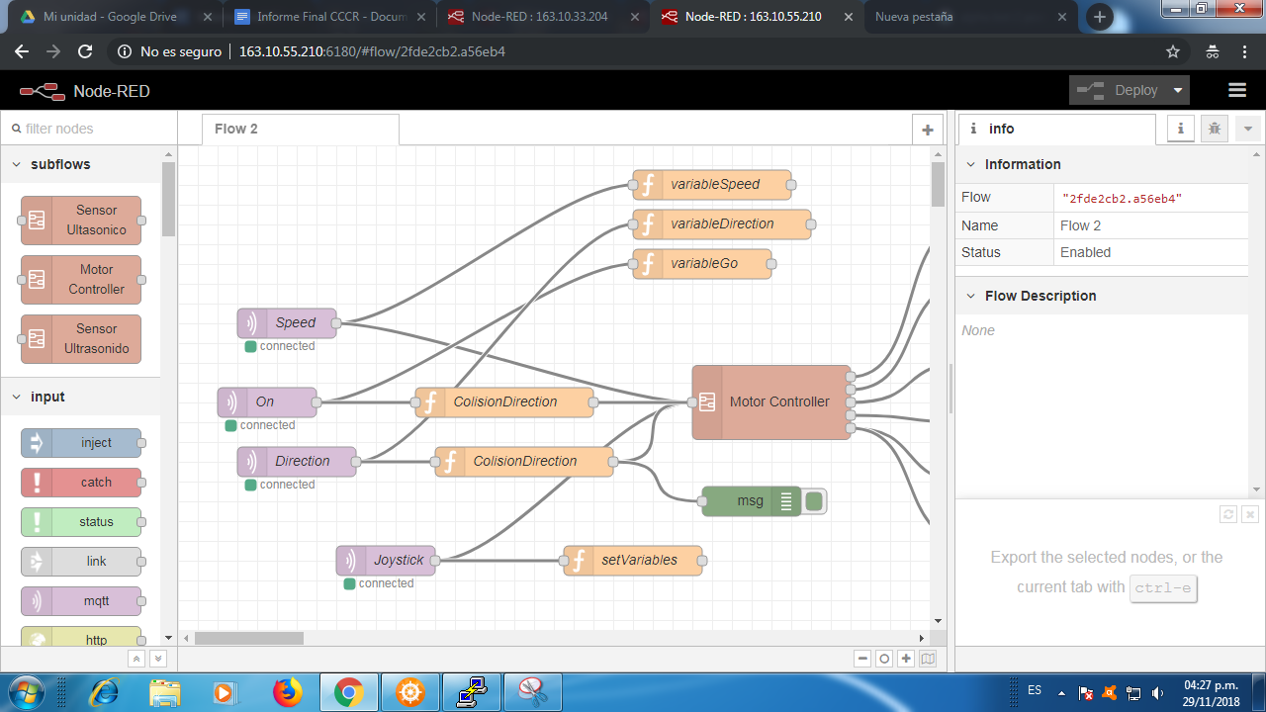

Ya adentro encontramos un Subflow también proporcionado por la cátedra llamado Motor Controller.

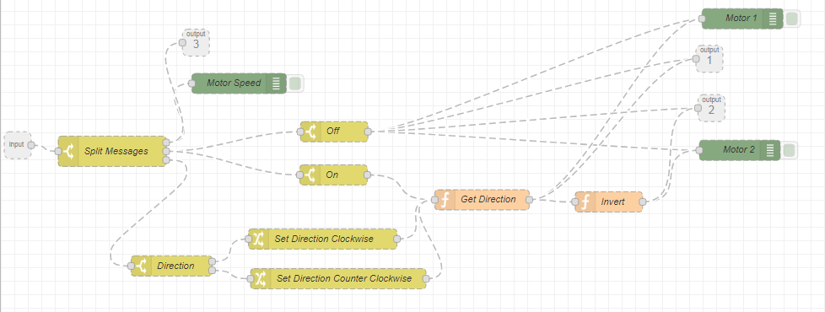

Este posee una entrada y tres salidas. La entrada va a un nodo Switch que separa los mensajes según su tópico: On, Speed o Direction. On refiere a si el motor está prendido o apagado, Speed refiere a la velocidad del motor, Direction al sentido que toma el robot.

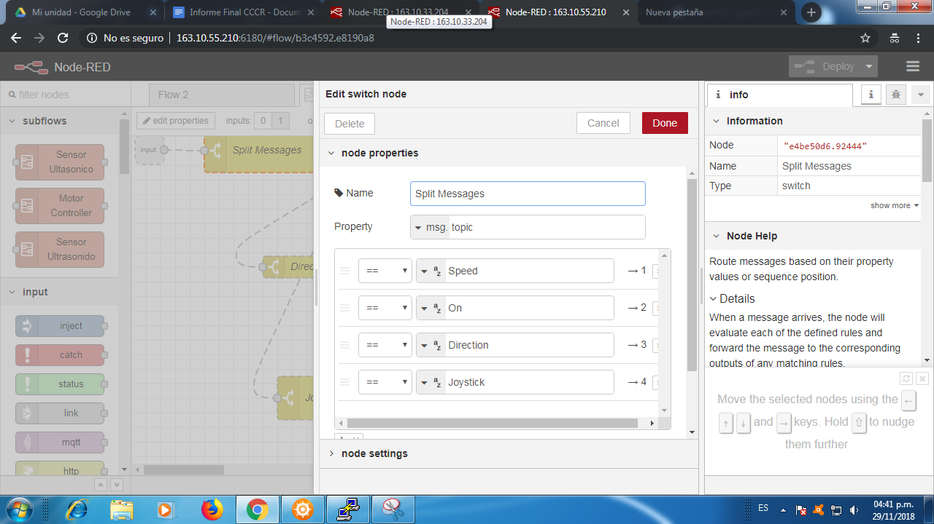

Aplicando lo aprendido en las prácticas anteriores vamos a utilizar una VM con Node-RED instalado llamada Cloud Robotics que funcionará como publicador (PUB) y creamos un flujo con botones conectados como entrada a un Nodo MQTT (referido a cada uno de los tópicos).

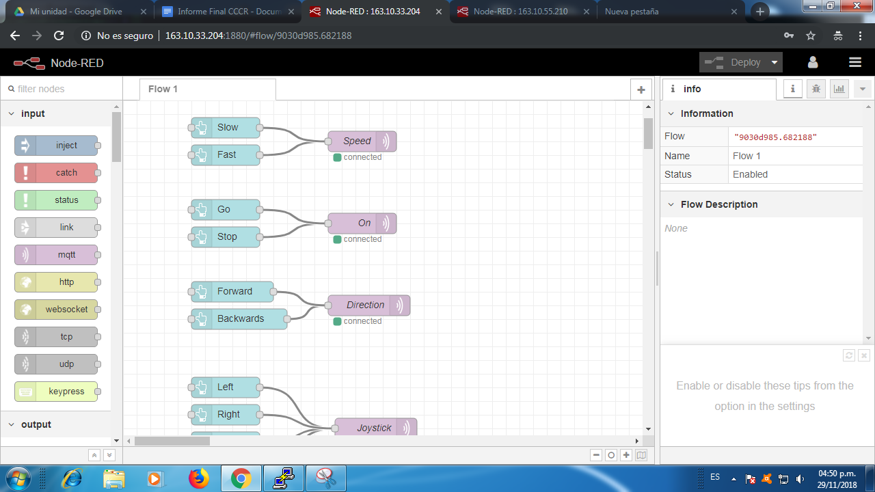

En el tópico Speed aplicamos dos entradas: Slow y Fast que son las distintas velocidades (20 y 45 respectivamente).

En el tópico On aplicamos las entradas Go para que se mueva y Stop para que pare (un 1 y un 0 respectivamente).

Y en el tópico Direction aplicamos Forward para que vaya hacia adelante y Backwards para que vaya hacia atrás (un 1 y un 0 respectivamente).

También abrimos una máquina “BROKER” con Mosquitto instalado para crear la conexión entre la máquina que publica (Cloud Robotics) y la máquina que se suscribe (RaspberryPi).

En el Node-RED de la Raspberry Pi agregamos nodos MQTT como entrada al subflow Motor Controller. Las salidas de los nodos serán, según las variables ingresadas en cada tópico: la velocidad de cada rueda, el sentido del giro de cada rueda y si se mueve o no.

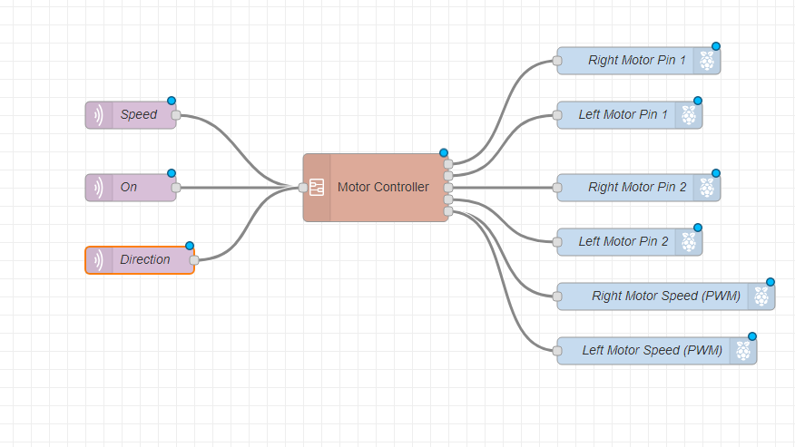

Una vez efectuada la conexión creamos un Dashboard para controlar desde ahí el Motor.

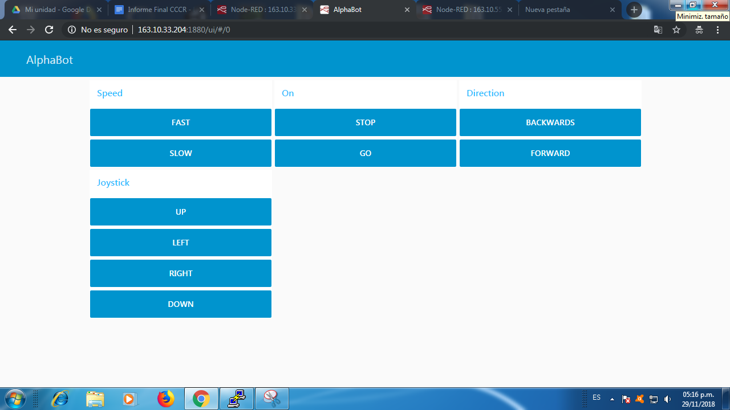

Cuando esto funcionó decidimos añadir la funcionalidad del sensor ultrasónico. Revisamos la biblioteca del Alphabot y analizamos los ejemplos del sensor.

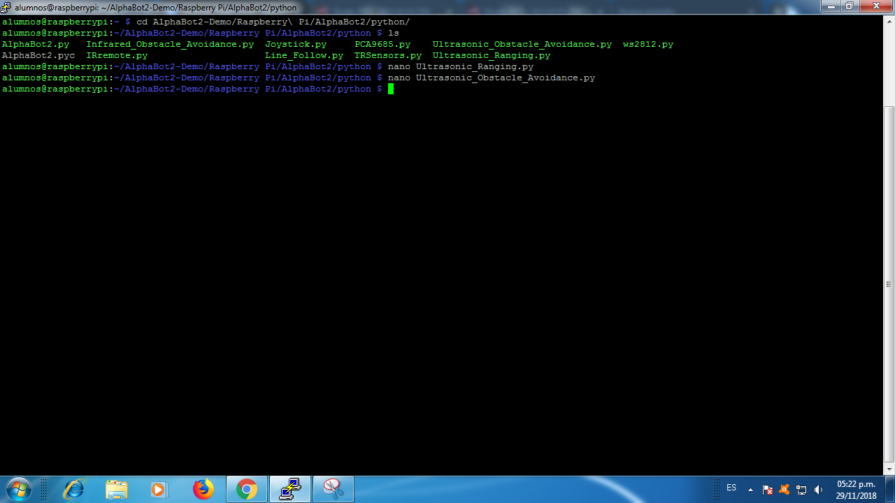

Intentamos implementar en Node-RED lo mismo que en el código de Python. Luego de unas horas de intentarlo nos dimos cuenta que la funcionalidad del sensor ya estaba implementada en un nodo que luego instalamos llamado **rpi srf**.

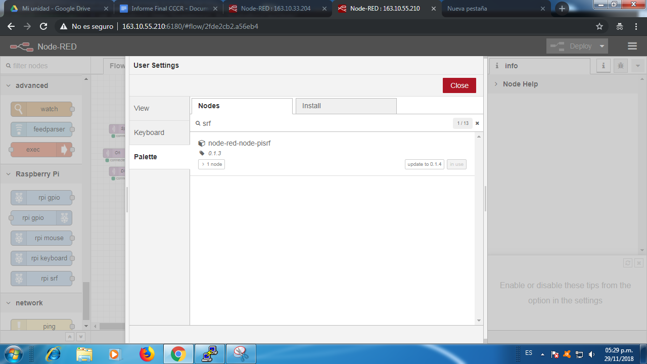

Con este nodo todo se torna más simple ya que podemos capturar la distancia que mide el sensor y, pasando por una función, decidir la acción que toma el robot.

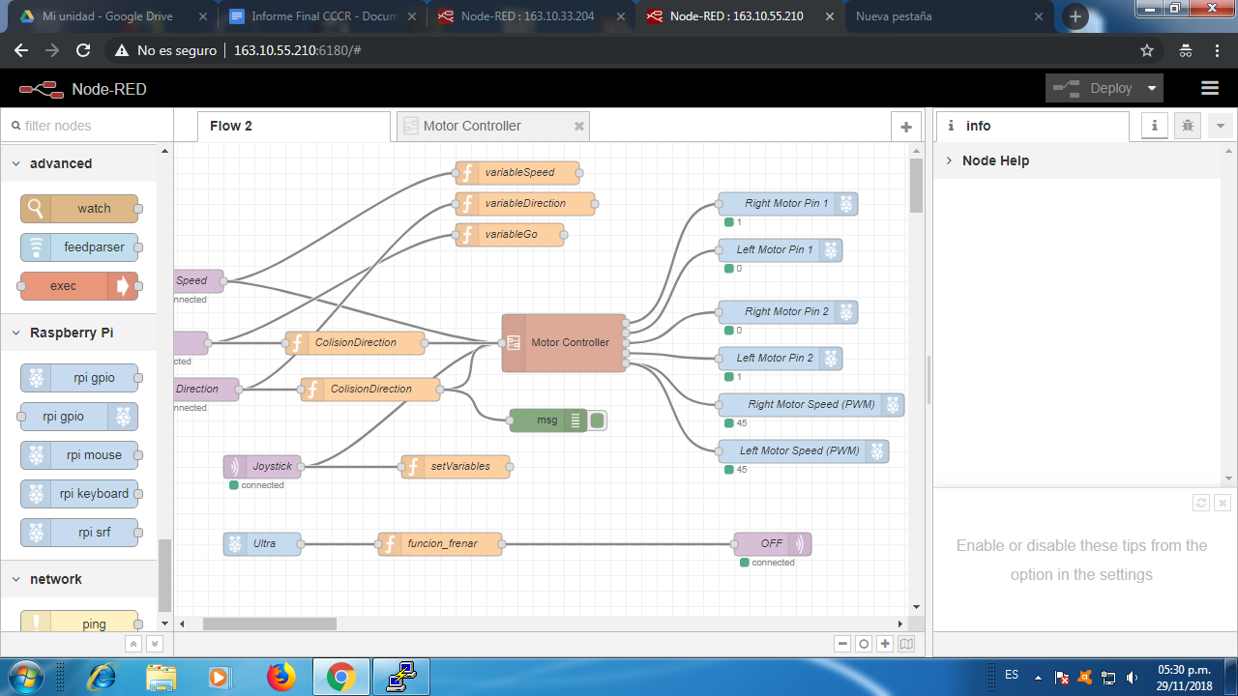

En este caso, si la velocidad del motor Fast y la distancia al objeto que detecta es menor a 50 centímetros, se pasa a la velocidad Slow. Si se sigue avanzando y el objeto se encuentra a menos de 20 centímetros el robot detiene su marcha. Si el objeto se aleja se vuelve a mover hacia adelante.



Para obtener las variables de entrada al Controlador, creamos funciones que asignan las entradas a variables globales y simplifican la consultas a los datos.

Estas son:

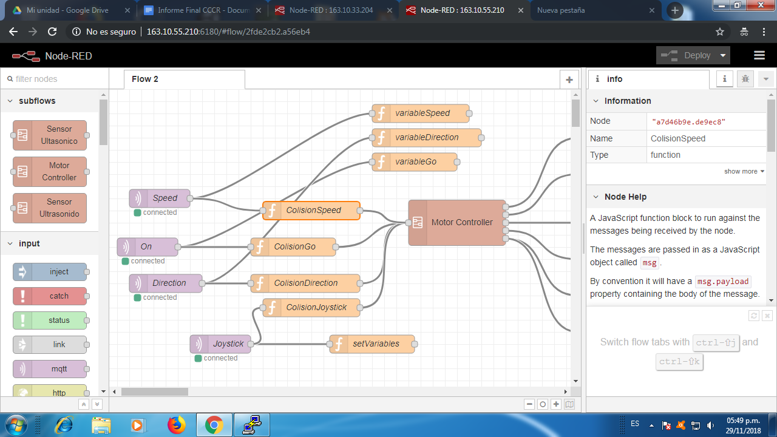

La forma en la que toman los datos (a modo explicativo solo capturamos una de ellas) es la siguiente:

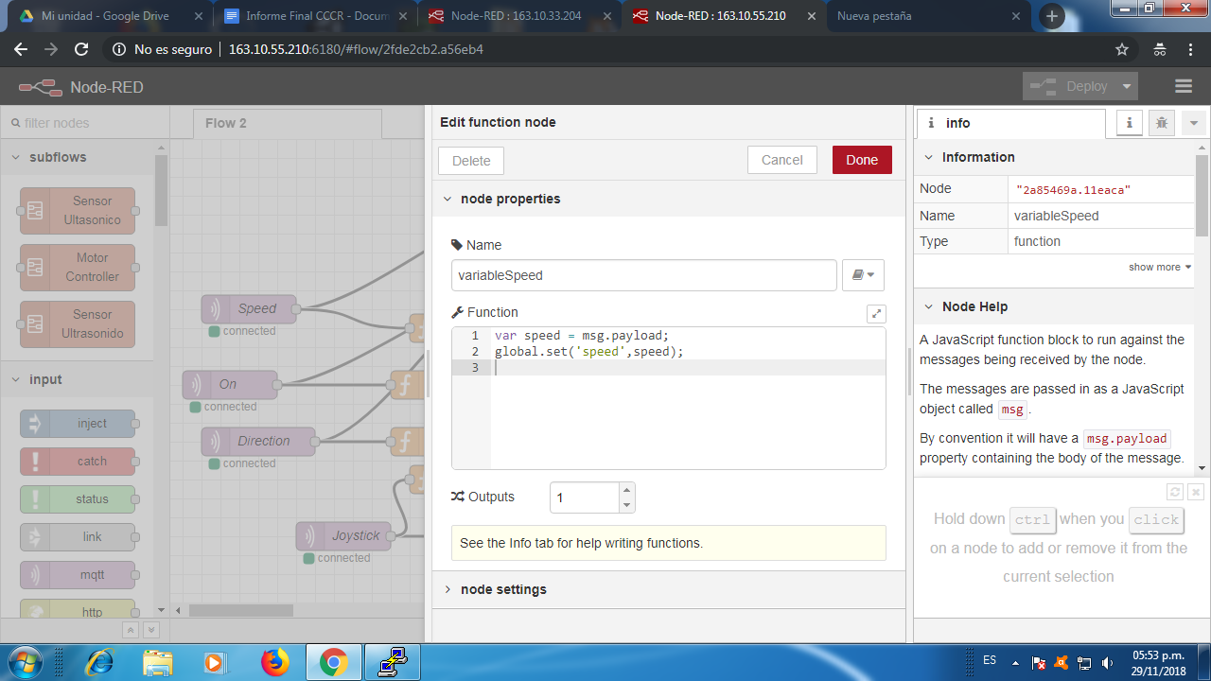

Explicado esto podemos presentar las funciones que manejan el cambio de velocidad y el frenado según las distancias del sensor ultrasónico.

funcion_disminuirVelocidad:

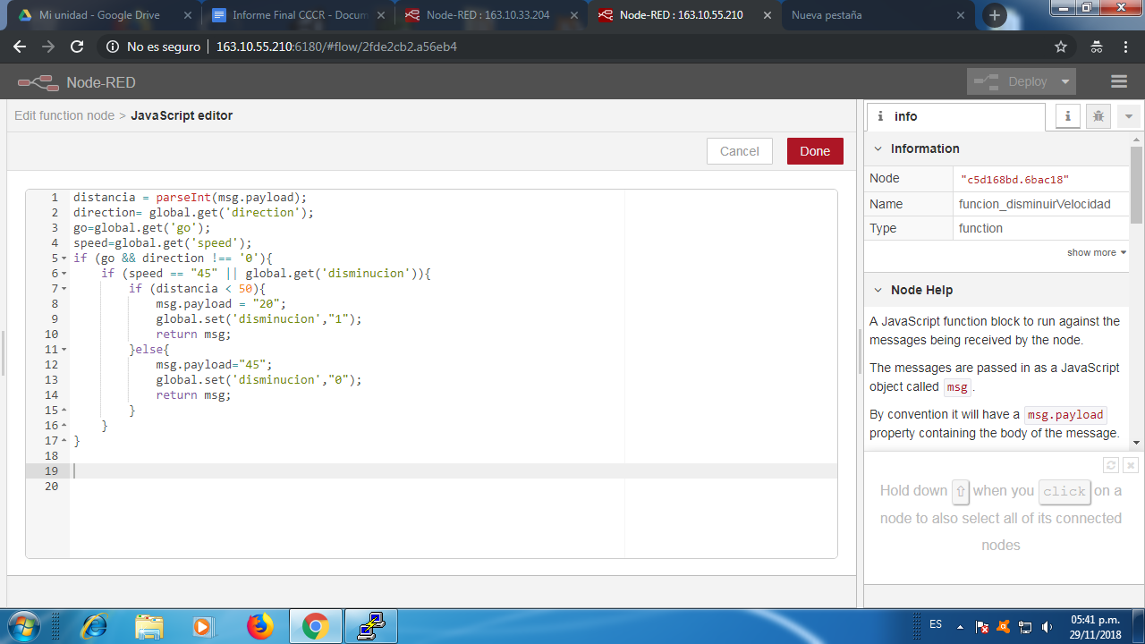

funcion_frenar:

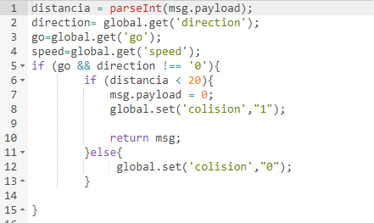

Para evitar que el robot realice movimientos indeseados cuando hay un objeto delante agregamos funciones “Colisión”.

*ColisionSpeed* evita que el usuario pueda pasar del nivel de velocidad Slow a Fast en el caso de que la variable global ‘disminución’ esté activa. Esta variable se activa cada vez que el sensor ultrasónico del AlphaBot detecta un objeto a menos de 50 centímetros. 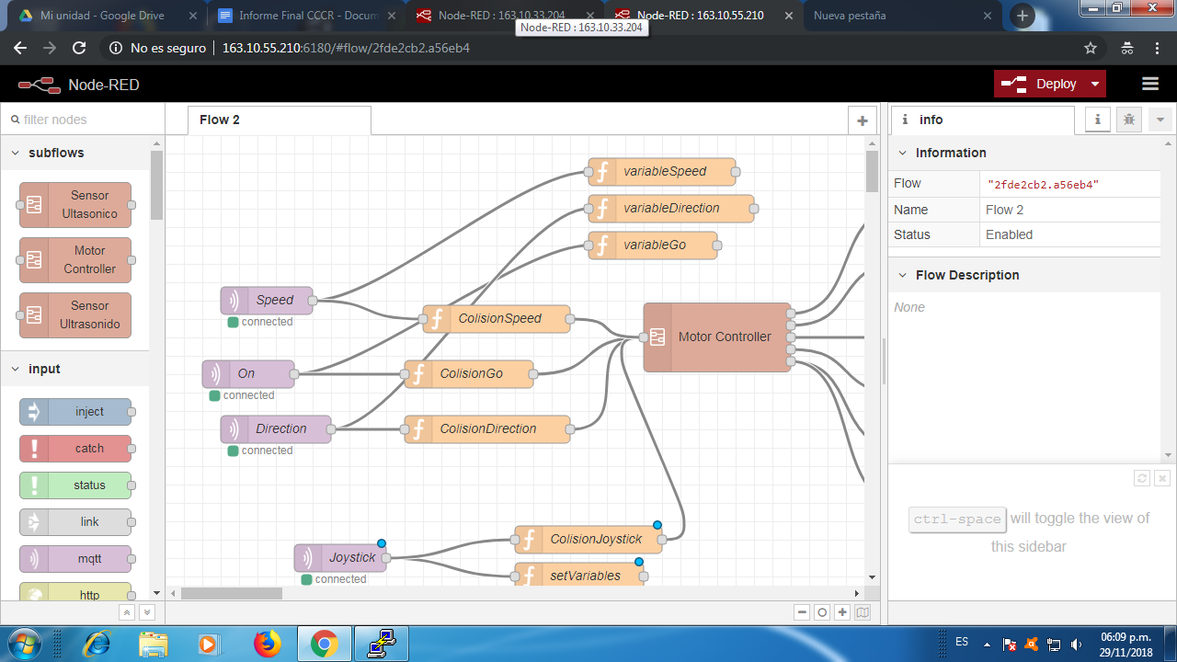

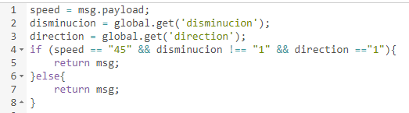

*ColisionGo* y *ColisionDirection* evitan que pase el valor forward o go al motor en el caso de que la variable global ‘colision’ este activa. Esta variable se activa cada vez que el sensor ultrasónico del AlphaBot detecta un objeto a menos de 20 centímetros.

*ColisionGo*:

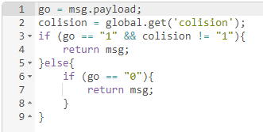

*ColisionDirection*

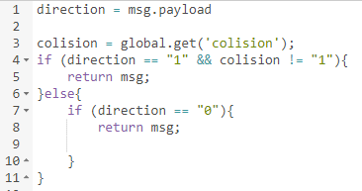

Una vez que logramos hacer funcionar el frenado y la disminución de la velocidad se nos ocurrió que sería interesante poder manejar el robot de forma remota y para esto utilizamos la aplicación Remote XY que permite agregar diferentes controles (botones, joystick, etc) en una APP de Android y así controlar el movimiento.

La aplicación con los controles agregados quedó de la siguiente forma:

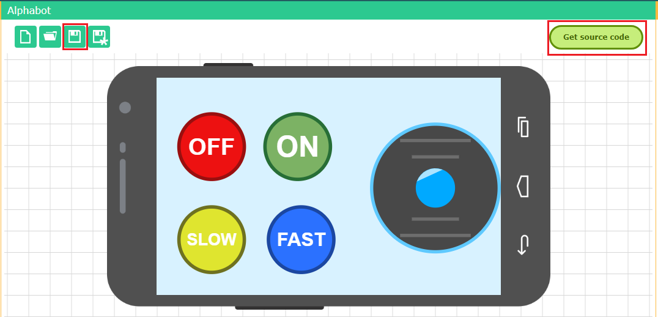

En nuestro celular se ve de la siguiente manera:

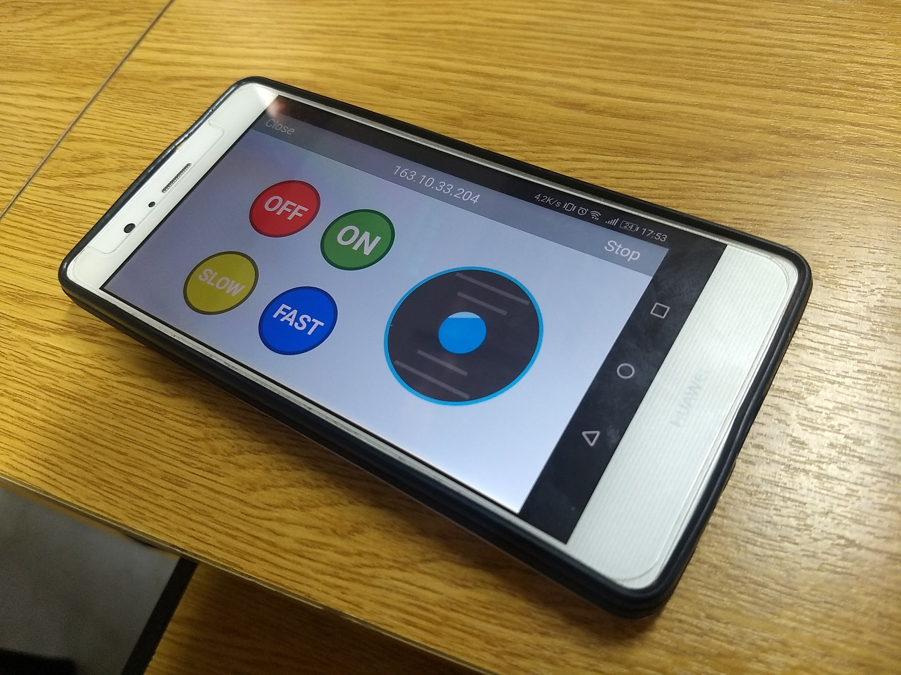

Para poder efectuar la conexión entre la APP y lo hecho en Node-RED debemos realizar varios pasos:

-Configurar Remote XY:

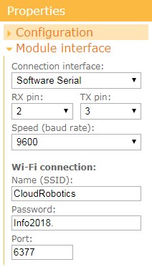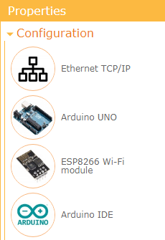

Elegimos Ethernet TCP/IP y configuramos el nombre de la red, la contraseña y el puerto que es el 6377. También habilitamos el puerto en Virtual Box.

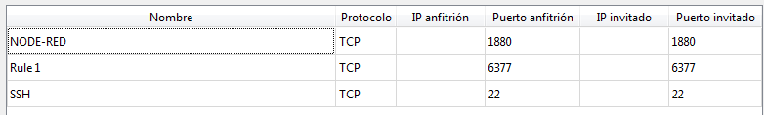

Configuramos cada uno de los componentes. 4 botones y un joystick.

Configuración del joystick: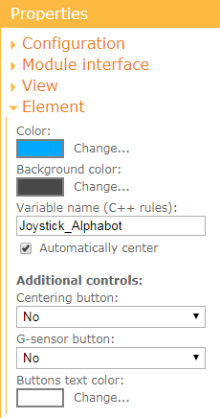

Configuración del botón On:

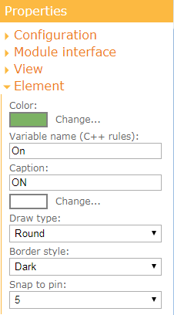

Configuración del botón Off:

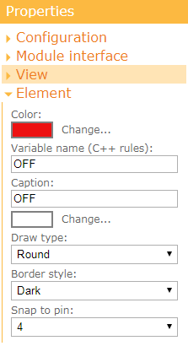

Configuración del botón Slow:

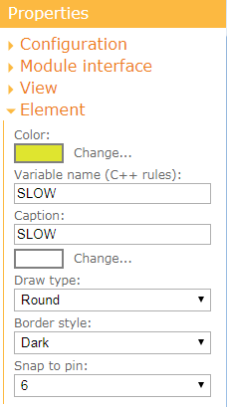

Configuración del botón Fast:

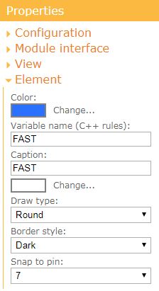

Luego guardamos y exportamos el código fuente para importarlo en Node-RED, no sin antes instalar el nodo **node-red-contrib-remote-xy**:

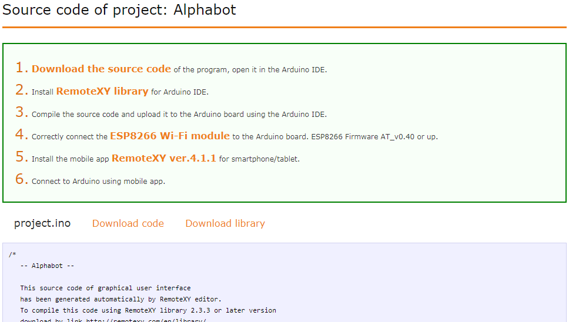

Cabe destacar que debemos configurar el nodo en el puerto 6377.

Pegamos el código fuente cuando editamos este nodo:

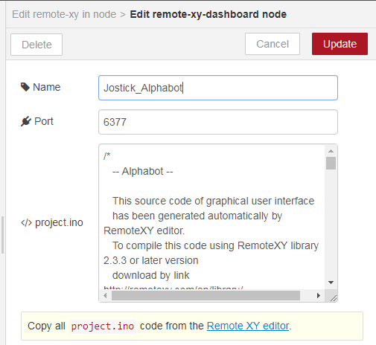

Y armamos un flujo en Node-RED para utilizar como entrada a los nodos MQTT los nodos remote xy recientemente configurados (botones On, Off, Slow y Fast).

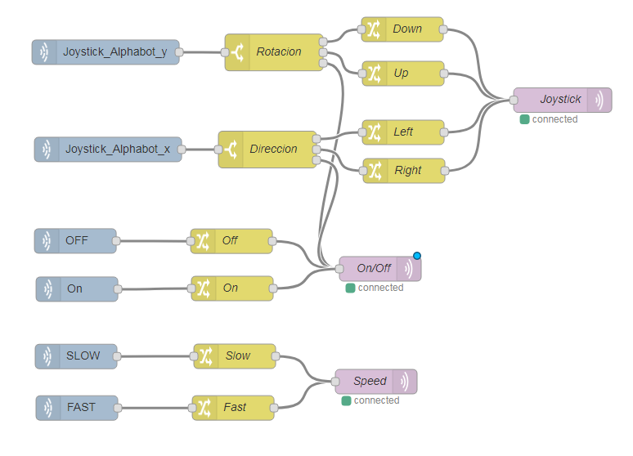

En el flujo de la Raspberry

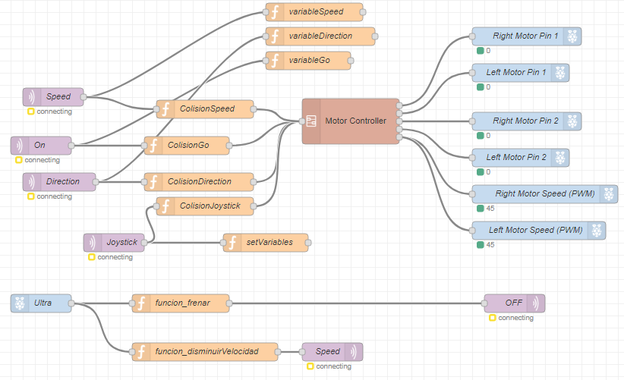

Y dentro del subflujo Motor Controller añadimos nodos de control respectivos al joystick:

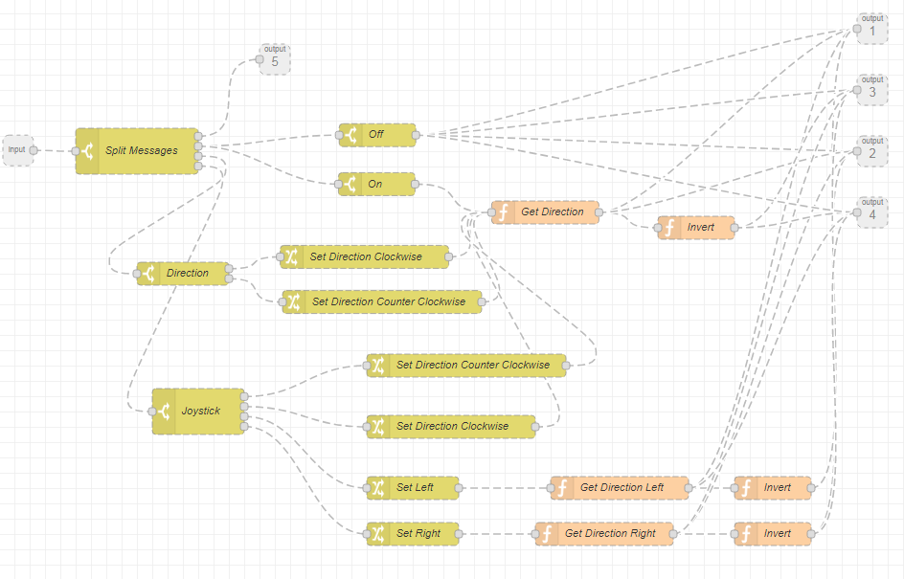

Agregamos una nodo de colisión para evitar que el mensaje de ‘UP’ llegue al controlador del motor si el sensor detecta un objeto.

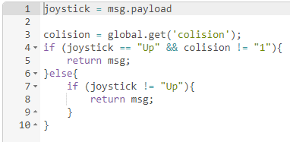

La aplicación de RemoteXY devuelve unos valores entre -100 y 100 tanto para el eje X como el eje Y a la hora de controlar el joystick. Para tener un mejor control en el Alphabot establecimos los márgenes entre 70 y 100. Cuando se suelta el Joystick, este vuelve al centro devolviendo un valor igual a 0, esta tercer salida es enviada por el tópico ON para que el Alphabot se deje de mover.

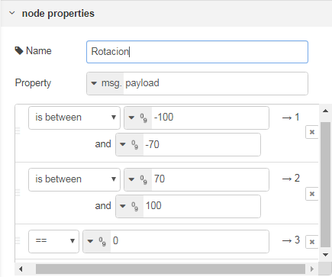

Los nodos Change sirven para transformar las entradas numéricas del RemoteXY a salidas alfabéticas para poder comunicarnos correctamente con el controlador del motor.

Por ejemplo:

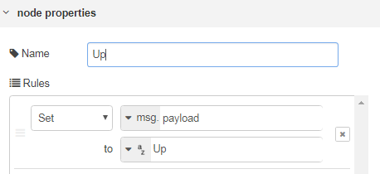

De esta forma logramos que el robot pueda ser manejado en forma remota y adicionalmente tenga las funciones de frenado y disminución de velocidad cuando el sensor ultrasónico detecte ciertas distancias.

FLOW del PUB

[{"id":"2d7cf081.51983","type":"tab","label":"Flow 1","disabled":false,"info":""},{"id":"321d8400.36d36c","type":"ui_base","theme":{"name":"theme-light","lightTheme":{"default":"#0094CE","baseColor":"#0094CE","baseFont":"-apple-system,BlinkMacSystemFont,Segoe UI,Roboto,Oxygen-Sans,Ubuntu,Cantarell,Helvetica Neue,sans-serif","edited":true,"reset":false},"darkTheme":{"default":"#097479","baseColor":"#097479","baseFont":"-apple-system,BlinkMacSystemFont,Segoe UI,Roboto,Oxygen-Sans,Ubuntu,Cantarell,Helvetica Neue,sans-serif","edited":false},"customTheme":{"name":"Untitled Theme 1","default":"#4B7930","baseColor":"#4B7930","baseFont":"-apple-system,BlinkMacSystemFont,Segoe UI,Roboto,Oxygen-Sans,Ubuntu,Cantarell,Helvetica Neue,sans-serif"},"themeState":{"base-color":{"default":"#0094CE","value":"#0094CE","edited":false},"page-titlebar-backgroundColor":{"value":"#0094CE","edited":false},"page-backgroundColor":{"value":"#fafafa","edited":false},"page-sidebar-backgroundColor":{"value":"#ffffff","edited":false},"group-textColor":{"value":"#1bbfff","edited":false},"group-borderColor":{"value":"#ffffff","edited":false},"group-backgroundColor":{"value":"#ffffff","edited":false},"widget-textColor":{"value":"#111111","edited":false},"widget-backgroundColor":{"value":"#0094ce","edited":false},"widget-borderColor":{"value":"#ffffff","edited":false},"base-font":{"value":"-apple-system,BlinkMacSystemFont,Segoe UI,Roboto,Oxygen-Sans,Ubuntu,Cantarell,Helvetica Neue,sans-serif"}}},"site":{"name":"Node-RED Dashboard","hideToolbar":"false","allowSwipe":"false","allowTempTheme":"true","dateFormat":"DD/MM/YYYY","sizes":{"sx":48,"sy":48,"gx":6,"gy":6,"cx":6,"cy":6,"px":0,"py":0}}},{"id":"e772cf09.c9d67","type":"ui_tab","z":"","name":"Botones LEDs","icon":"dashboard","order":1},{"id":"88bfd574.9edb68","type":"ui_group","z":"","name":"LEDs","tab":"e772cf09.c9d67","order":1,"disp":true,"width":"6","collapse":false},{"id":"d7b398e5.ab8718","type":"mqtt-broker","z":"","name":"MQTT","broker":"163.10.33.204","port":"1883","clientid":"","usetls":false,"compatmode":true,"keepalive":"60","cleansession":true,"birthTopic":"","birthQos":"0","birthPayload":"","closeTopic":"","closeQos":"0","closePayload":"","willTopic":"","willQos":"0","willPayload":""},{"id":"4e55b158.f78a3","type":"remote-xy-dashboard","z":"","name":"App","port":"6377","config":"/* \n -- Alphabot -- \n \n This source code of graphical user interface \n has been generated automatically by RemoteXY editor. \n To compile this code using RemoteXY library 2.3.3 or later version \n download by link http://remotexy.com/en/library/ \n To connect using RemoteXY mobile app by link http://remotexy.com/en/download/ \n - for ANDROID 4.1.1 or later version; \n - for iOS 1.2.1 or later version; \n \n This source code is free software; you can redistribute it and/or \n modify it under the terms of the GNU Lesser General Public \n License as published by the Free Software Foundation; either \n version 2.1 of the License, or (at your option) any later version. \n*/ \n\n////////////////////////////////////////////// \n// RemoteXY include library // \n////////////////////////////////////////////// \n\n// RemoteXY select connection mode and include library \n#define REMOTEXY_MODE__ESP8266_SOFTSERIAL\n#include <SoftwareSerial.h> \n\n#include <RemoteXY.h> \n\n// RemoteXY connection settings \n#define REMOTEXY_SERIAL_RX 2 \n#define REMOTEXY_SERIAL_TX 3 \n#define REMOTEXY_SERIAL_SPEED 9600 \n#define REMOTEXY_WIFI_SSID \"CloudRobotics\" \n#define REMOTEXY_WIFI_PASSWORD \"Info2018.\" \n#define REMOTEXY_SERVER_PORT 6377 \n\n\n// RemoteXY configurate \n#pragma pack(push, 1) \nuint8_t RemoteXY_CONF[] = \n { 255,6,0,0,0,61,0,8,181,0,\n 5,32,62,13,38,38,177,26,31,1,\n 0,6,10,20,20,1,31,79,70,70,\n 0,1,0,31,10,20,20,4,31,79,\n 78,0,1,0,6,37,20,20,3,31,\n 83,76,79,87,0,1,0,32,37,20,\n 20,191,31,70,65,83,84,0 }; \n \n// this structure defines all the variables of your control interface \nstruct { \n\n // input variable\n int8_t Joystick_Alphabot_x; // =-100..100 x-coordinate joystick position \n int8_t Joystick_Alphabot_y; // =-100..100 y-coordinate joystick position \n uint8_t OFF; // =1 if button pressed, else =0 \n uint8_t On; // =1 if button pressed, else =0 \n uint8_t SLOW; // =1 if button pressed, else =0 \n uint8_t FAST; // =1 if button pressed, else =0 \n\n // other variable\n uint8_t connect_flag; // =1 if wire connected, else =0 \n\n} RemoteXY; \n#pragma pack(pop) \n\n///////////////////////////////////////////// \n// END RemoteXY include // \n///////////////////////////////////////////// \n\n#define PIN_OFF 4\n#define PIN_ON 5\n#define PIN_SLOW 6\n#define PIN_FAST 7\n\n\nvoid setup() \n{ \n RemoteXY_Init (); \n \n pinMode (PIN_OFF, OUTPUT);\n pinMode (PIN_ON, OUTPUT);\n pinMode (PIN_SLOW, OUTPUT);\n pinMode (PIN_FAST, OUTPUT);\n \n // TODO you setup code \n \n} \n\nvoid loop() \n{ \n RemoteXY_Handler (); \n \n digitalWrite(PIN_OFF, (RemoteXY.OFF==0)?LOW:HIGH);\n digitalWrite(PIN_ON, (RemoteXY.On==0)?LOW:HIGH);\n digitalWrite(PIN_SLOW, (RemoteXY.SLOW==0)?LOW:HIGH);\n digitalWrite(PIN_FAST, (RemoteXY.FAST==0)?LOW:HIGH);\n \n // TODO you loop code \n // use the RemoteXY structure for data transfer \n\n\n}"},{"id":"247cf588.1c297a","type":"remote-xy in","z":"2d7cf081.51983","name":"Joystick_Alphabot_y","dashboard":"4e55b158.f78a3","index":"1","x":167.079833984375,"y":83.90624904632568,"wires":[["49d5cb87.e46214"]]},{"id":"fb0d8566.289b28","type":"remote-xy in","z":"2d7cf081.51983","name":"remote-xy","dashboard":"4e55b158.f78a3","index":"0","x":140.0729217529297,"y":202.91670608520508,"wires":[["39a6abfd.954cf4"]]},{"id":"8aac88ed.af94a8","type":"remote-xy in","z":"2d7cf081.51983","name":"OFF","dashboard":"4e55b158.f78a3","index":"2","x":130.07983016967773,"y":314.9027910232544,"wires":[["329b6605.647e4a"]]},{"id":"1c1444d5.5bae2b","type":"remote-xy in","z":"2d7cf081.51983","name":"On","dashboard":"4e55b158.f78a3","index":"3","x":132.08332443237305,"y":373.9097852706909,"wires":[["95e941ac.858b"]]},{"id":"bd544a37.824478","type":"remote-xy in","z":"2d7cf081.51983","name":"SLOW","dashboard":"4e55b158.f78a3","index":"4","x":131.01733016967773,"y":456.23266410827637,"wires":[["88cb6a76.86b2a8"]]},{"id":"9a0c3dbf.9289d","type":"remote-xy in","z":"2d7cf081.51983","name":"FAST","dashboard":"4e55b158.f78a3","index":"5","x":132.0173225402832,"y":519.2328205108643,"wires":[["ad3cc8ee.e94fc8"]]},{"id":"5dbfae6e.4f459","type":"mqtt out","z":"2d7cf081.51983","name":"Joystick","topic":"Joystick","qos":"","retain":"","broker":"d7b398e5.ab8718","x":726.0832481384277,"y":142.53823471069336,"wires":[]},{"id":"bfc346c7.88c978","type":"mqtt out","z":"2d7cf081.51983","name":"On/Off","topic":"On","qos":"","retain":"","broker":"d7b398e5.ab8718","x":496.01734161376953,"y":345.0104112625122,"wires":[]},{"id":"9858d15d.e7ccf","type":"mqtt out","z":"2d7cf081.51983","name":"Speed","topic":"Speed","qos":"","retain":"","broker":"d7b398e5.ab8718","x":498.01733779907227,"y":487.01051330566406,"wires":[]},{"id":"db4cf0db.d779d","type":"change","z":"2d7cf081.51983","name":"Up","rules":[{"t":"set","p":"payload","pt":"msg","to":"Up","tot":"str"}],"action":"","property":"","from":"","to":"","reg":false,"x":531.0174255371094,"y":110.01042556762695,"wires":[["5dbfae6e.4f459"]]},{"id":"4355a7e7.2040e8","type":"change","z":"2d7cf081.51983","name":"Down","rules":[{"t":"set","p":"payload","pt":"msg","to":"Down","tot":"str"}],"action":"","property":"","from":"","to":"","reg":false,"x":530.0173683166504,"y":56.01044273376465,"wires":[["5dbfae6e.4f459"]]},{"id":"81be8fd9.de88d","type":"change","z":"2d7cf081.51983","name":"Left","rules":[{"t":"set","p":"payload","pt":"msg","to":"Left","tot":"str"}],"action":"","property":"","from":"","to":"","reg":false,"x":531.0173416137695,"y":182.0104694366455,"wires":[["5dbfae6e.4f459"]]},{"id":"5179b626.754ae8","type":"change","z":"2d7cf081.51983","name":"Right","rules":[{"t":"set","p":"payload","pt":"msg","to":"Right","tot":"str"}],"action":"","property":"","from":"","to":"","reg":false,"x":532.0173683166504,"y":229.01044082641602,"wires":[["5dbfae6e.4f459"]]},{"id":"49d5cb87.e46214","type":"switch","z":"2d7cf081.51983","name":"Rotacion","property":"payload","propertyType":"msg","rules":[{"t":"btwn","v":"-100","vt":"num","v2":"-70","v2t":"num"},{"t":"btwn","v":"70","vt":"num","v2":"100","v2t":"num"},{"t":"eq","v":"0","vt":"num"}],"checkall":"true","repair":false,"outputs":3,"x":373.08338165283203,"y":84.1701431274414,"wires":[["4355a7e7.2040e8"],["db4cf0db.d779d"],["bfc346c7.88c978"]]},{"id":"39a6abfd.954cf4","type":"switch","z":"2d7cf081.51983","name":"Direccion","property":"payload","propertyType":"msg","rules":[{"t":"btwn","v":"-100","vt":"num","v2":"-70","v2t":"num"},{"t":"btwn","v":"70","vt":"num","v2":"100","v2t":"num"},{"t":"eq","v":"0","vt":"num"}],"checkall":"true","repair":false,"outputs":3,"x":365.01738357543945,"y":203.01043224334717,"wires":[["81be8fd9.de88d"],["5179b626.754ae8"],["bfc346c7.88c978"]]},{"id":"329b6605.647e4a","type":"change","z":"2d7cf081.51983","name":"Off","rules":[{"t":"set","p":"payload","pt":"msg","to":"0","tot":"str"}],"action":"","property":"","from":"","to":"","reg":false,"x":321.0729522705078,"y":315.1354503631592,"wires":[["bfc346c7.88c978"]]},{"id":"95e941ac.858b","type":"change","z":"2d7cf081.51983","name":"On","rules":[{"t":"set","p":"payload","pt":"msg","to":"1","tot":"str"}],"action":"","property":"","from":"","to":"","reg":false,"x":322.01736068725586,"y":373.01042652130127,"wires":[["bfc346c7.88c978"]]},{"id":"ad3cc8ee.e94fc8","type":"change","z":"2d7cf081.51983","name":"Fast","rules":[{"t":"set","p":"payload","pt":"msg","to":"45","tot":"str"}],"action":"","property":"","from":"","to":"","reg":false,"x":323.0764389038086,"y":519.145917892456,"wires":[["9858d15d.e7ccf"]]},{"id":"88cb6a76.86b2a8","type":"change","z":"2d7cf081.51983","name":"Slow","rules":[{"t":"set","p":"payload","pt":"msg","to":"20","tot":"str"}],"action":"","property":"","from":"","to":"","reg":false,"x":325.01739501953125,"y":456.0104503631592,"wires":[["9858d15d.e7ccf"]]}]

FLOW del Alphabot

[{"id":"2fde2cb2.a56eb4","type":"tab","label":"Flow 2","disabled":false,"info":""},{"id":"14f8f27.5f5640e","type":"subflow","name":"Sensor Ultasonico","info":"","category":"","in":[{"x":60,"y":200,"wires":[{"id":"5a08e30.64d911c"}]}],"out":[{"x":660,"y":360,"wires":[{"id":"b7ac08f6.467048","port":0}]}]},{"id":"b3c4592.e8190a8","type":"subflow","name":"Motor Controller","info":"Expects different messages\nAn \"On\" message and a \"Direction\" message","in":[{"x":25,"y":219,"wires":[{"id":"e4be50d6.92444"}]}],"out":[{"x":1140,"y":60,"wires":[{"id":"672110be.f1345","port":0},{"id":"b15c1374.75d39","port":0},{"id":"f3f2d922.4b17c8","port":0},{"id":"4302ba8e.38f164","port":0}]},{"x":1140,"y":220,"wires":[{"id":"672110be.f1345","port":0},{"id":"b15c1374.75d39","port":0},{"id":"93b28666.4a2de8","port":0},{"id":"11893d39.8acb43","port":0}]},{"x":1140,"y":140,"wires":[{"id":"672110be.f1345","port":0},{"id":"5f470f3e.384f7","port":0},{"id":"93b28666.4a2de8","port":0},{"id":"11893d39.8acb43","port":0}]},{"x":1140,"y":300,"wires":[{"id":"5f470f3e.384f7","port":0},{"id":"672110be.f1345","port":0},{"id":"f3f2d922.4b17c8","port":0},{"id":"4302ba8e.38f164","port":0}]},{"x":360,"y":100,"wires":[{"id":"e4be50d6.92444","port":0}]}]},{"id":"43e627be.821b68","type":"subflow","name":"Sensor Ultrasonido","info":"","category":"","in":[{"x":60,"y":240,"wires":[{"id":"15a35a84.02a335"}]}],"out":[]},{"id":"41cafe1c.53397","type":"mqtt-broker","z":"","name":"MOSQUITTO","broker":"163.10.33.204","port":"1883","clientid":"","usetls":false,"compatmode":true,"keepalive":"60","cleansession":true,"birthTopic":"","birthQos":"0","birthPayload":"","closeTopic":"","closeQos":"0","closePayload":"","willTopic":"","willQos":"0","willPayload":""},{"id":"e4204ebb.6fd0a","type":"rpi-gpio in","z":"14f8f27.5f5640e","name":"Echo","pin":"13","intype":"tri","debounce":"25","read":false,"x":70,"y":420,"wires":[["8d501fdb.d3edb"]]},{"id":"e6652976.bf00e8","type":"rpi-gpio out","z":"14f8f27.5f5640e","name":"Trigger","pin":"15","set":true,"level":"0","freq":"","out":"out","x":600,"y":260,"wires":[]},{"id":"9683f86a.fe1998","type":"inject","z":"14f8f27.5f5640e","name":"Reset","topic":"","payload":"1","payloadType":"num","repeat":"","crontab":"","once":true,"onceDelay":"1","x":190,"y":60,"wires":[[]]},{"id":"b7ac08f6.467048","type":"function","z":"14f8f27.5f5640e","name":"Calcular Time","func":"while (!flow.echo && !flow.trig){\n}\nvar t1 = new Date().getTime();\nwhile (flow.echo && !flow.trig ){\n}\nvar t2 = new Date().getTime();\nreturn (t2-t1)*34000/2;","outputs":1,"noerr":0,"x":520,"y":360,"wires":[[]]},{"id":"8d501fdb.d3edb","type":"change","z":"14f8f27.5f5640e","name":"","rules":[{"t":"move","p":"payload","pt":"msg","to":"echo","tot":"flow"}],"action":"","property":"","from":"","to":"","reg":false,"x":310,"y":420,"wires":[["b7ac08f6.467048"]]},{"id":"21cf6f66.1a52e","type":"change","z":"14f8f27.5f5640e","name":"","rules":[{"t":"move","p":"payload","pt":"msg","to":"trig","tot":"flow"}],"action":"","property":"","from":"","to":"","reg":false,"x":290,"y":340,"wires":[["b7ac08f6.467048"]]},{"id":"e4be50d6.92444","type":"switch","z":"b3c4592.e8190a8","name":"Split Messages","property":"topic","propertyType":"msg","rules":[{"t":"eq","v":"Speed","vt":"str"},{"t":"eq","v":"On","vt":"str"},{"t":"eq","v":"Direction","vt":"str"},{"t":"eq","v":"Joystick","vt":"str"}],"checkall":"true","repair":false,"outputs":4,"x":180,"y":220,"wires":[[],["672110be.f1345","fcf22bb1.4ea708"],["5ea7bce.d02e044"],["f027b801.109358"]]},{"id":"672110be.f1345","type":"switch","z":"b3c4592.e8190a8","name":"Off","property":"payload","propertyType":"msg","rules":[{"t":"eq","v":"0","vt":"str"}],"checkall":"true","repair":false,"outputs":1,"x":494,"y":199,"wires":[[]]},{"id":"fcf22bb1.4ea708","type":"switch","z":"b3c4592.e8190a8","name":"On","property":"payload","propertyType":"msg","rules":[{"t":"eq","v":"1","vt":"str"}],"checkall":"true","repair":false,"outputs":1,"x":493,"y":263,"wires":[["b15c1374.75d39"]]},{"id":"6881d47.553c92c","type":"change","z":"b3c4592.e8190a8","name":"Set Direction Clockwise","rules":[{"t":"set","p":"direction","pt":"flow","to":"1","tot":"num"}],"action":"","property":"","from":"","to":"","reg":false,"x":477,"y":358,"wires":[["b15c1374.75d39"]]},{"id":"b07096eb.f5e118","type":"change","z":"b3c4592.e8190a8","name":"Set Direction Counter Clockwise","rules":[{"t":"set","p":"direction","pt":"flow","to":"0","tot":"num"}],"action":"","property":"","from":"","to":"","reg":false,"x":500,"y":417,"wires":[["b15c1374.75d39"]]},{"id":"b15c1374.75d39","type":"function","z":"b3c4592.e8190a8","name":"Get Direction","func":"var direction = flow.get('direction')||0;\nmsg.payload = direction;\nreturn msg;","outputs":1,"noerr":0,"x":713,"y":300,"wires":[["5f470f3e.384f7"]]},{"id":"5f470f3e.384f7","type":"function","z":"b3c4592.e8190a8","name":"Invert","func":"if (msg.payload == 1) {\n msg.payload = 0;\n}\nelse\n{\n msg.payload = 1;\n}\nreturn msg;","outputs":1,"noerr":0,"x":910,"y":320,"wires":[[]]},{"id":"5ea7bce.d02e044","type":"switch","z":"b3c4592.e8190a8","name":"Direction","property":"payload","propertyType":"msg","rules":[{"t":"eq","v":"0","vt":"str"},{"t":"eq","v":"1","vt":"str"}],"checkall":"true","repair":false,"outputs":2,"x":240,"y":380,"wires":[["6881d47.553c92c"],["b07096eb.f5e118"]]},{"id":"c76b4208.e684d","type":"rpi-gpio out","z":"2fde2cb2.a56eb4","name":"Right Motor Speed (PWM)","pin":"31","set":"","level":"0","freq":"50","out":"pwm","x":920,"y":340,"wires":[]},{"id":"2394885f.5f6178","type":"rpi-gpio out","z":"2fde2cb2.a56eb4","name":"Right Motor Pin 1","pin":"32","set":true,"level":"0","freq":"","out":"out","x":890,"y":80,"wires":[]},{"id":"568107f0.b37248","type":"rpi-gpio out","z":"2fde2cb2.a56eb4","name":"Right Motor Pin 2","pin":"33","set":true,"level":"0","freq":"","out":"out","x":890,"y":220,"wires":[]},{"id":"134554c3.8858ab","type":"subflow:b3c4592.e8190a8","z":"2fde2cb2.a56eb4","name":"","x":600,"y":220,"wires":[["2394885f.5f6178"],["69a13940.a1e8b8"],["568107f0.b37248"],["bdb7b19a.d3173"],["c76b4208.e684d","ba6ca138.39c9d"]]},{"id":"69a13940.a1e8b8","type":"rpi-gpio out","z":"2fde2cb2.a56eb4","name":"Left Motor Pin 1","pin":"38","set":true,"level":"0","freq":"","out":"out","x":880,"y":140,"wires":[]},{"id":"bdb7b19a.d3173","type":"rpi-gpio out","z":"2fde2cb2.a56eb4","name":"Left Motor Pin 2","pin":"40","set":true,"level":"0","freq":"","out":"out","x":880,"y":280,"wires":[]},{"id":"ba6ca138.39c9d","type":"rpi-gpio out","z":"2fde2cb2.a56eb4","name":"Left Motor Speed (PWM)","pin":"37","set":"","level":"0","freq":"50","out":"pwm","x":910,"y":400,"wires":[]},{"id":"60f8094f.bfd2a8","type":"mqtt in","z":"2fde2cb2.a56eb4","name":"Speed","topic":"Speed","qos":"2","broker":"41cafe1c.53397","x":110,"y":180,"wires":[["2a85469a.11eaca","a7d46b9e.de9ec8"]]},{"id":"8994e0ae.98bc","type":"mqtt in","z":"2fde2cb2.a56eb4","name":"On","topic":"On","qos":"2","broker":"41cafe1c.53397","x":90,"y":260,"wires":[["e9b85af2.2d8528","d1b83f28.56a6a"]]},{"id":"a76f8306.083d1","type":"mqtt in","z":"2fde2cb2.a56eb4","name":"Direction","topic":"Direction","qos":"2","broker":"41cafe1c.53397","x":120,"y":320,"wires":[["e0e8abcb.8bb958","af14d2a3.2547d"]]},{"id":"9d31b193.ffa0a","type":"debug","z":"14f8f27.5f5640e","name":"MORITE","active":true,"tosidebar":true,"console":false,"tostatus":false,"complete":"true","x":560,"y":140,"wires":[]},{"id":"d7a73c59.1c6eb","type":"trigger","z":"14f8f27.5f5640e","op1":"1","op2":"0","op1type":"str","op2type":"str","duration":"15","extend":false,"units":"ms","reset":"1","bytopic":"all","name":"Signal","x":370,"y":260,"wires":[["e6652976.bf00e8","21cf6f66.1a52e","9d31b193.ffa0a"]]},{"id":"5a08e30.64d911c","type":"change","z":"14f8f27.5f5640e","name":"Hola","rules":[{"t":"move","p":"payload","pt":"msg","to":"trig","tot":"flow"}],"action":"","property":"","from":"","to":"","reg":false,"x":150,"y":240,"wires":[["d7a73c59.1c6eb"]]},{"id":"15a35a84.02a335","type":"trigger","z":"43e627be.821b68","op1":"1","op2":"0","op1type":"str","op2type":"str","duration":"15","extend":false,"units":"ms","reset":"","bytopic":"all","name":"","x":310,"y":240,"wires":[["c348f51f.f33348","1d48416b.3842af"]]},{"id":"c348f51f.f33348","type":"rpi-gpio out","z":"43e627be.821b68","name":"Trigger","pin":"15","set":true,"level":"0","freq":"","out":"out","x":520,"y":220,"wires":[]},{"id":"1d48416b.3842af","type":"function","z":"43e627be.821b68","name":"Calcular Time","func":"while (!flow.echo ){\n \n}\nreturn 1;\n//var t1 = new Date().getTime();\n//while (flow.echo && !flow.trig ){\n//}\n//var t2 = new Date().getTime();\n//return (t2-t1)*34000/2;","outputs":1,"noerr":0,"x":440,"y":380,"wires":[["cbb2ceb3.6f9f2"]]},{"id":"cbb2ceb3.6f9f2","type":"debug","z":"43e627be.821b68","name":"","active":true,"tosidebar":true,"console":false,"tostatus":false,"complete":"false","x":640,"y":400,"wires":[]},{"id":"fcc60111.24652","type":"rpi-srf","z":"2fde2cb2.a56eb4","name":"Ultra","topic":"SRF","pulse":"0.5","pins":"15,13","x":90,"y":520,"wires":[["c305bd1c.8d302","c5d168bd.6bac18"]]},{"id":"f3024a31.489298","type":"mqtt out","z":"2fde2cb2.a56eb4","name":"OFF","topic":"On","qos":"2","retain":"","broker":"41cafe1c.53397","x":870,"y":520,"wires":[]},{"id":"f73f6de9.fa37c","type":"mqtt in","z":"2fde2cb2.a56eb4","name":"Joystick","topic":"Joystick","qos":"2","broker":"41cafe1c.53397","x":210,"y":420,"wires":[["5d2f1b77.646da4","9aee244e.e5e8b8"]]},{"id":"8365254b.b77878","type":"change","z":"b3c4592.e8190a8","name":"Set Direction Clockwise","rules":[{"t":"set","p":"direction","pt":"flow","to":"1","tot":"num"}],"action":"","property":"","from":"","to":"","reg":false,"x":590,"y":580,"wires":[["b15c1374.75d39"]]},{"id":"fa0da7db.c669b8","type":"change","z":"b3c4592.e8190a8","name":"Set Direction Counter Clockwise","rules":[{"t":"set","p":"direction","pt":"flow","to":"0","tot":"num"}],"action":"","property":"","from":"","to":"","reg":false,"x":610,"y":500,"wires":[["b15c1374.75d39"]]},{"id":"f95a0768.eecad8","type":"change","z":"b3c4592.e8190a8","name":"Set Left","rules":[{"t":"set","p":"direction","pt":"flow","to":"1","tot":"str"}],"action":"","property":"","from":"","to":"","reg":false,"x":540,"y":660,"wires":[["f3f2d922.4b17c8"]]},{"id":"51684ac.7bcb9b4","type":"change","z":"b3c4592.e8190a8","name":"Set Right","rules":[{"t":"set","p":"payload","pt":"msg","to":"","tot":"str"}],"action":"","property":"","from":"","to":"","reg":false,"x":540,"y":720,"wires":[["11893d39.8acb43"]]},{"id":"f3f2d922.4b17c8","type":"function","z":"b3c4592.e8190a8","name":"Get Direction Left","func":"var direction = flow.get('direction')||0;\nmsg.payload = direction;\nreturn msg;","outputs":1,"noerr":0,"x":810,"y":660,"wires":[["93b28666.4a2de8"]]},{"id":"93b28666.4a2de8","type":"function","z":"b3c4592.e8190a8","name":"Invert","func":"if (msg.payload == 1) {\n msg.payload = 0;\n}\nelse\n{\n msg.payload = 1;\n}\nreturn msg;","outputs":1,"noerr":0,"x":1010,"y":660,"wires":[[]]},{"id":"11893d39.8acb43","type":"function","z":"b3c4592.e8190a8","name":"Get Direction Right","func":"var direction = flow.get('direction')||0;\nmsg.payload = direction;\nreturn msg;","outputs":1,"noerr":0,"x":790,"y":720,"wires":[["4302ba8e.38f164"]]},{"id":"4302ba8e.38f164","type":"function","z":"b3c4592.e8190a8","name":"Invert","func":"if (msg.payload == 1) {\n msg.payload = 0;\n}\nelse\n{\n msg.payload = 1;\n}\nreturn msg;","outputs":1,"noerr":0,"x":1010,"y":720,"wires":[[]]},{"id":"e9b85af2.2d8528","type":"function","z":"2fde2cb2.a56eb4","name":"variableGo","func":"var go = msg.payload;\nglobal.set('go',go);\n","outputs":1,"noerr":0,"x":530,"y":120,"wires":[[]]},{"id":"e0e8abcb.8bb958","type":"function","z":"2fde2cb2.a56eb4","name":"variableDirection","func":"var direction = msg.payload;\nglobal.set('direction',direction);\n","outputs":1,"noerr":0,"x":550,"y":80,"wires":[[]]},{"id":"2a85469a.11eaca","type":"function","z":"2fde2cb2.a56eb4","name":"variableSpeed","func":"var speed = msg.payload;\nglobal.set('speed',speed);\n","outputs":1,"noerr":0,"x":540,"y":40,"wires":[[]]},{"id":"c305bd1c.8d302","type":"function","z":"2fde2cb2.a56eb4","name":"funcion_frenar","func":"distancia = parseInt(msg.payload);\ndirection= global.get('direction');\ngo=global.get('go');\nspeed=global.get('speed');\nif (go && direction !== '0'){\n if (distancia < 20){\n msg.payload = 0;\n global.set('colision',\"1\");\n \n return msg;\n }else{\n global.set('colision',\"0\");\n }\n \n}\n\n\n","outputs":1,"noerr":0,"x":320,"y":520,"wires":[["f3024a31.489298"]]},{"id":"5d2f1b77.646da4","type":"function","z":"2fde2cb2.a56eb4","name":"setVariables","func":"joystick = msg.payload;\nswitch(joystick) {\n case \"Up\":\n\n global.set('go',\"1\");\n global.set('direction',\"1\");\n break;\n case \"Down\":\n \n global.set('go',\"1\");\n global.set('direction',\"0\");\n break;\n case \"Left\":\n \n global.set('go',\"1\");\n global.set('direction',\"0\");\n break;\n case \"Right\":\n\n global.set('go',\"1\");\n global.set('direction',\"0\");\n break;\n}","outputs":1,"noerr":0,"x":460,"y":420,"wires":[[]]},{"id":"af14d2a3.2547d","type":"function","z":"2fde2cb2.a56eb4","name":"ColisionDirection","func":"direction = msg.payload\n\ncolision = global.get('colision');\nif (direction == \"1\" && colision != \"1\"){\n return msg;\n}else{\n if (direction == \"0\"){\n return msg;\n \n }\n}","outputs":1,"noerr":0,"x":350,"y":320,"wires":[["134554c3.8858ab"]]},{"id":"d1b83f28.56a6a","type":"function","z":"2fde2cb2.a56eb4","name":"ColisionGo","func":"go = msg.payload;\ncolision = global.get('colision');\nif (go == \"1\" && colision != \"1\"){\n return msg;\n}else{\n if (go == \"0\"){\n return msg;\n }\n}","outputs":1,"noerr":0,"x":330,"y":260,"wires":[["134554c3.8858ab"]]},{"id":"9aee244e.e5e8b8","type":"function","z":"2fde2cb2.a56eb4","name":"ColisionJoystick","func":"joystick = msg.payload\n\ncolision = global.get('colision');\nif (joystick == \"Up\" && colision != \"1\"){\n return msg;\n}else{\n if (joystick != \"Up\"){\n return msg;\n }\n}","outputs":1,"noerr":0,"x":360,"y":360,"wires":[["134554c3.8858ab"]]},{"id":"abb53902.97dca8","type":"mqtt out","z":"2fde2cb2.a56eb4","name":"Speed","topic":"Speed","qos":"","retain":"","broker":"41cafe1c.53397","x":570,"y":600,"wires":[]},{"id":"c5d168bd.6bac18","type":"function","z":"2fde2cb2.a56eb4","name":"funcion_disminuirVelocidad","func":"distancia = parseInt(msg.payload);\ndirection= global.get('direction');\ngo=global.get('go');\nspeed=global.get('speed');\nif (go && direction !== '0'){\n if ( distancia < 50){\n if (speed == \"45\"){\n msg.payload = \"20\";\n global.set('disminucion',\"1\");\n return msg;\n }\n }else{\n if (global.get('disminucion') == \"1\") {\n global.set('disminucion',\"0\");\n msg.payload=\"45\";\n return msg;\n }\n \n }\n \n}\n\n\n\n\n","outputs":1,"noerr":0,"x":360,"y":600,"wires":[["abb53902.97dca8"]]},{"id":"a7d46b9e.de9ec8","type":"function","z":"2fde2cb2.a56eb4","name":"ColisionSpeed","func":"speed = msg.payload;\ndisminucion = global.get('disminucion');\ndirection = global.get('direction');\nif (speed == \"45\" && disminucion !== \"1\" && direction ==\"1\"){\n return msg;\n}else{\n return msg;\n}","outputs":1,"noerr":0,"x":360,"y":200,"wires":[["134554c3.8858ab"]]},{"id":"f027b801.109358","type":"switch","z":"b3c4592.e8190a8","name":"Joystick","property":"payload","propertyType":"msg","rules":[{"t":"eq","v":"Up","vt":"str"},{"t":"eq","v":"Down","vt":"str"},{"t":"eq","v":"Left","vt":"str"},{"t":"eq","v":"Right","vt":"str"}],"checkall":"true","repair":false,"outputs":4,"x":260,"y":560,"wires":[["fa0da7db.c669b8"],["8365254b.b77878"],["f95a0768.eecad8"],["51684ac.7bcb9b4"]]}]